

Computer Games Development - CW208
GDD
Year IV

Project Name: Cavebound

Andrew Greenslade
C00246189

Started: 18/10/2022
Completed: TBD

Contents

Acknowledgements 4
Game Overview 5
Feature Set 5
General Features 5
Multiplayer Features 5
Editor 5
Gameplay 5
The Game World 6
Overview 6
The Physical World 6
Overview 6
Key Locations 6
Travel 6
Scale 6
Objects 6
Weather 6
Day and Night 6
Time 7
Rendering System 8
Overview 8
2D/3D Rendering 8
Camera 8
Overview 8
Camera Detail #1 8
Camera Detail #2 8
Game Engine 9
Overview 9
Game Engine Detail #1 9
Water 9
Collision Detection 9
The World Layout 10
Overview 10
World Layout Detail #1 10
World Layout Detail #2 10
Game Characters 11
Overview 11
Creating a Character 11
Enemies and Monsters 11
User Interface 11
Overview 11
User Interface Detail #1 11
User Interface Detail #2 11
Weapons 12
Overview 12
Weapons Details #1 12
Weapons Details #2 12
Musical Scores and Sound Effects 12
Overview 12
Red Book Audio 12
3D Sound 12
Sound Design 12
Single-Player Game 13
Overview 13
Single Player Game Detail #1 13
Single Player Game Detail #2 13
Story 13
Hours of Gameplay 13
Victory Conditions 13
Multiplayer Game 13
Overview 13
Max Players 14
Servers 14
Customization 14
Internet 14
Game Sites 14
Persistence 14
Saving and Loading 14
Character Rendering 15
Overview 15
Character Rendering Detail #1 15
Character Rendering Detail #2 15
World Editing 15
Overview 15
World Editing Detail #1 15
World Editing Detail #2 15
References 16

Acknowledgements
We would like to thank the following people who assisted in completing this project including:

[NOT COMPLETED YET]

Game Overview

The game I am creating is a multiplayer online mining PVPVE game that is integrated with blockchain technologies and specifically an ecosystem and SDK provided by Enjin. I decided to create this game because I have a keen interest in blockchain technology including crypto-currencies and NFT’s, and it is somewhere that I haven’t explored in terms of integrating a game into these two technologies, so therefore I would learn a great amount of invaluable knowledge from this project.

The game, Cavebound is set in a different universe in the year 2042, where big corporations hire miners to drain a planets resource’s (ores) for money. Your goal is to mine the most ores in a set amount of time and store them in your mining ship. You can also choose to allow others to do this and steal their resources by eliminating them. The game is set on different planets that all have different themes and random world generations.

The person who has the most ores at the end of the game, will be victorious and wins. There will also be hostile Ai that will try to combat you if you get in their sight. The main two differences between this project to others are the random “loot box” style of rewards where the blockchain-based rewards are randomised.

The second feature being an achievement system that will reward players with the mentioned loot box rewards. An example of possible achievements being:
- Get your first player base elimination,
- Mine a certain criteria of ores in a single game session,
- Move a certain amount of meters in a single play session, etc.

Feature Set

General Features
- Randomly generated worlds that can be destroyed and mined.
- There will be a randomly generated planet with an earth like structure i.e. Made of stone, and a variety of ores like copper, diamond, iron, etc., which can all be destroyed/mined.
- Multiplayer Gameplay
- The game will be heavily focused around multiplayer gameplay, particularly 2 up to 4 players, where each player will spawn in their own corner of the map to start with.
- Blockchain integration
- The rewards of the game will be focused around a blockchain technology, either NFT’s or crypto-currencies
- Custom AI solution that integrates with custom world gen
- There will be an AI that integrates with the destructible world and its custom layout. This ai will have the ability to follow and fire a projectile at the player but will also have its grid updated to allow movement in destructible terrain.

Multiplayer Features

- Custom gamertag naming
- The player can choose a custom gamertag at the start of the game when creating a account for Enjin, to allow other players to distinguish them. This will be saved upon confirmation of the user login. It will also show a QR code and linking code, which both are for linking it to an Enjin wallet.
- Destructible terrain
- The world will be destructible and will sync between clients. Also, ore drops will be spawned network wide.
- Separate Safe “stash” inventory
  - You can choose to return to your home spawn to deposit ores to your stash inventory for safe keeping as when you die you drop your ores for other players to retrieve.

Gameplay

Before the gameplay there will be a player Gamertag creation screen, lobby selection screen and lobby screen.

- Gamertag selection screen
  - This will be a menu where you can input your choice for your gamertag/ username
- Lobby selection Menu
  - This is where you can choose what lobby you want to join, it will show the hosts name in a format like ‘AndrewG71’s lobby’
- Lobby screen
  - This screen will show everyone in the lobby’s gamertag as well as how many players are in it and will allow the host to start the game.

Games will last on average of 10-15 minutes, and will be based on whoever gets the most score wins, in a free for all arena.

The gameplay will start off with a player in each corner of the map, Each player can choose to fly around and destroy blocks with their weapons to progress through the map, their objective being to gather score through eliminating players, mining ores and eliminating AI. When the player chooses to mine ores, they have to take said ores back to their starting base to store them for points. In the meantime they have to watch out for other opponents as they can choose to eliminate the player and steal their resources for themselves.

The Game World

Overview
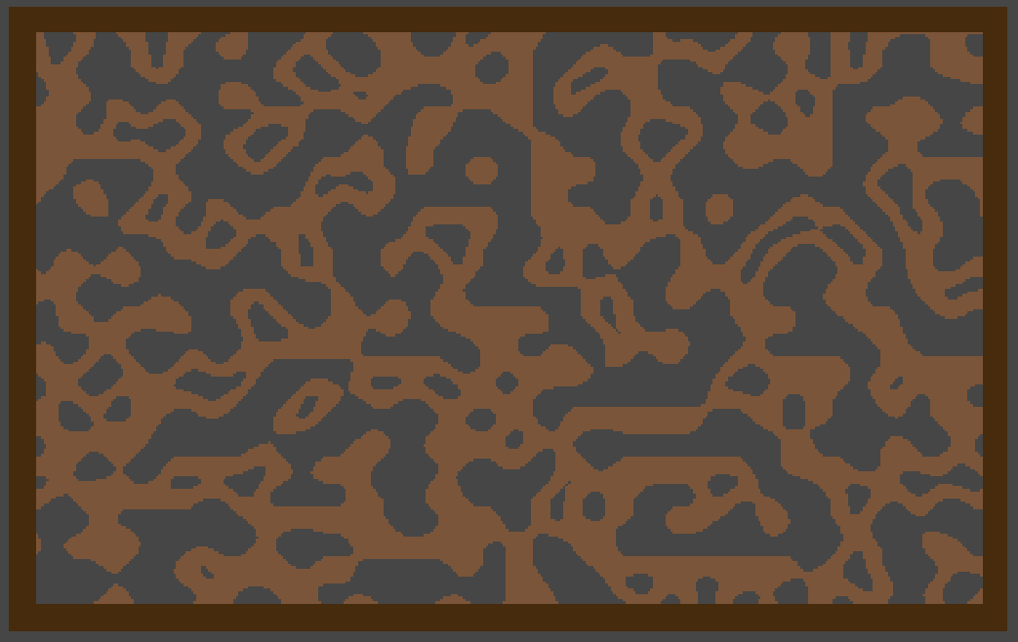
(An example of the randomised map generation in an early prototype stage, which is based on a dirt-like planet, no ores included yet)

World Feature #1 – Random map generation.
The map will be randomly generated to allow for a different gameplay experience every time. This will ensure the player will play for a longer time, as the map isn’t the same every lobby.

World Feature #2 – Random enemy spawning
The enemy’s will be randomly spawning in a radius around the player to ensure there is always a threat that the player must be aware from when moving. This gives the player that there is a sense of security to their mining ship as well.

The Physical World

Overview
The physical world will be generated using noise and will be completely random each time the player loads into different games. There is also ores that will spawn that the player can mine for their overall score.

Key Locations
The main key locations of the world would be each players mining ship, where they store their ores for score. They can also choose to upgrade their stats here for ore.

Travel
The player will move characters around the world by directly controlling them through their input device.

Scale
The scale of the world will be modular so I can make the randomly generated map bigger smaller depending on playtesting.

Objects
The main set of objects in the world is the ore blocks and ore drops independently, as mining these is the main objective of the game. These ore blocks and drops include:
- Iron
- Diamond
- Gold
- Silver
- Copper
The main other objects are: The player, the various projectiles (Player & AI), the Ai itself, and the players base ship.

Weather
Their will be no weather effects as you will be deep underground in each level.

Day and Night
No, the game does not have a day and night mode, their will always be darkness as you will be underground.

Time
[NEEDS TO BE DONE]
Describe the way time will work in your game or whatever will be used. Focus game timeline with three engaging minutes of gameplay. Create a timeline bubble and narrative for this. Each minute builds to an event and within each minute a series of engaging events occur. The tree minutes should where crescendo to a large event.


(An example of the 2D lighting and post processing in unity on the map generation)

Rendering System

Overview
The game will be set in a 2D environment and will feature rendering effects such as 2D lighting, tile-sets for improved performance, post processing for image effects, etc.

2D/3D Rendering
The game features 2D Rendering using Unity’s 2D systems as well as packages such as URP (universal Rendering Pipeline), Cinimachine, etc.

Camera

Overview
The camera will be in a following player like state majority of the time, but you can enter a zoomed out like state to view the map in a bigger view but stops the player from moving. This will only show the map in a blackout like state because of the 2d lighting.

Camera Detail #1 - following player mechanism

The camera drags behinds the player when moving as if there is a delay. This will be only subtle, so the player doesn’t feel sick when playing the game.

Camera Detail #2 - post processing
The camera will feature special post processing effects like Bloom, colour grading and Vignette to immerse the player even more.

Game Engine

Overview

The game engine I chose to use in this project was Unity because I had previous experience with it in 3D, but felt there was several areas I needed to improve on, like Multiplayer networking, AI and behaviours, 2D gameplay, procedural world generation, etc. So I chose to base the project around these areas so it was an all-round learning experience.

The game engine ‘Unity’ is one of the more accessible compared to others like unreal engine from my experience, hence where I Mentor in CoderDojo in the Gorey dojo, some of the other mentors teach unity and game design to the older and more advanced groups. Generally, its knowledge can be transferred to these more advanced platforms in areas like material editing, animating, World construction/scene editing, etc. the terminology also gets transferred across, like inspector, scene hierarchy, project view, etc.

Also, the engine is quite modular in nature as anything you can think of in terms on add-ons for a game engine, there is more than likely a pre-existing solution. Some examples include,

Game Engine Detail #1 – Game management

The game engine will keep track of certain aspects of the game world like Animations, multiplayer connections, Post processing, rendering (Camera, tile-maps, etc.), etc. this will allow me to focus on gameplay elements and the other focused mechanics of this project like crypto-integration, Ai mechanics & behaviours, etc.

Game Engine Detail #1 - custom Terrain generation

Using Unity’s tile-maps systems, I will integrate destructible, custom generated terrain that will allow the player to destroy the map to navigate its cave structures. this will allow for unique gameplay strategies each time the player starts a lobby.

Game Engine Detail #2 – Enemy AI with integration into destructible environment

Using custom scripts, I will integrate Ai movement and behaviours into the modifiable environment, so when they environment gets destroyed the ai can then navigate around the newly freed open space. This will ensure there is cat-and-mouse & risk-and-reward like gameplay to the game itself, so if feels like there is an unknown danger to exploring too far from your homebase/ship. The ai placement will also be random to allow for unique gameplay opportunities like luring the AI near other players ships, etc.

The World Layout
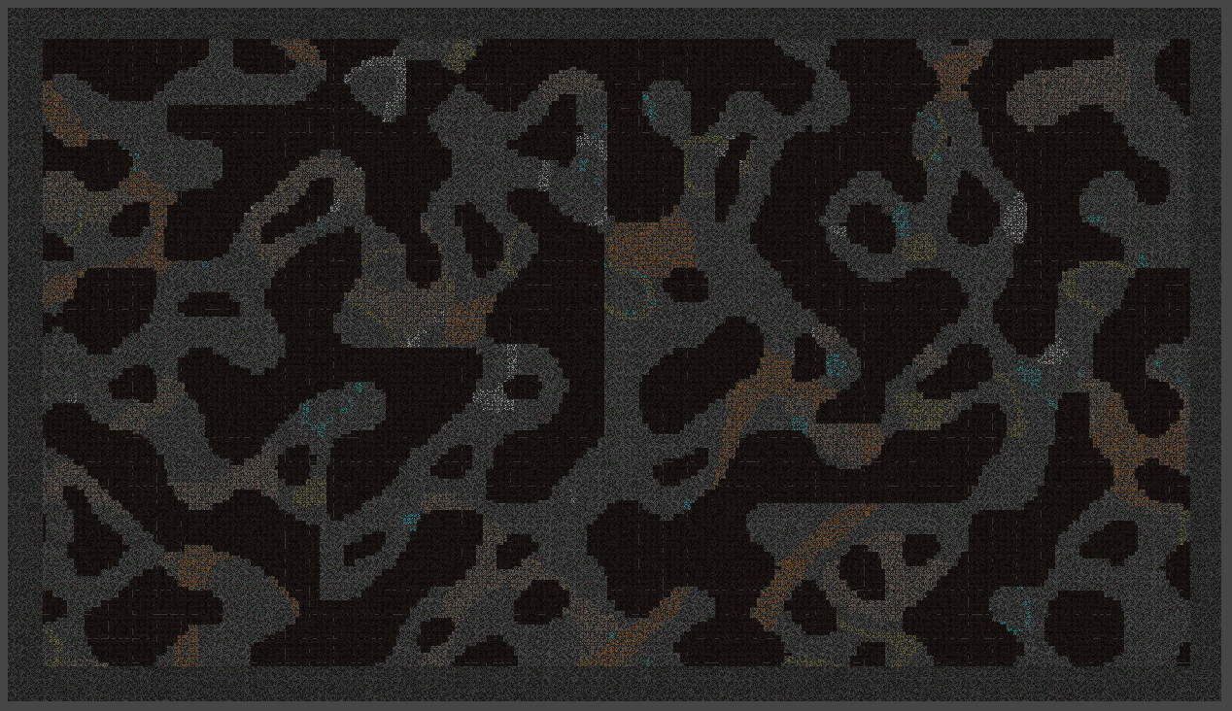

Overview

The world is made of separate randomly generated cave systems in a overall rectangular shape, it features a indestructible bedrock like border

World Layout Detail #1 – Bedrock border
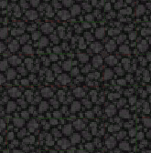
The Bedrock Border is made up of a darker stone, that can’t be destroyed. This is to make sure players wont just mine in a direction other player cant find them and to limit them to an fight to the death arena style of gameplay.

World Layout Detail #2 - Ore veins
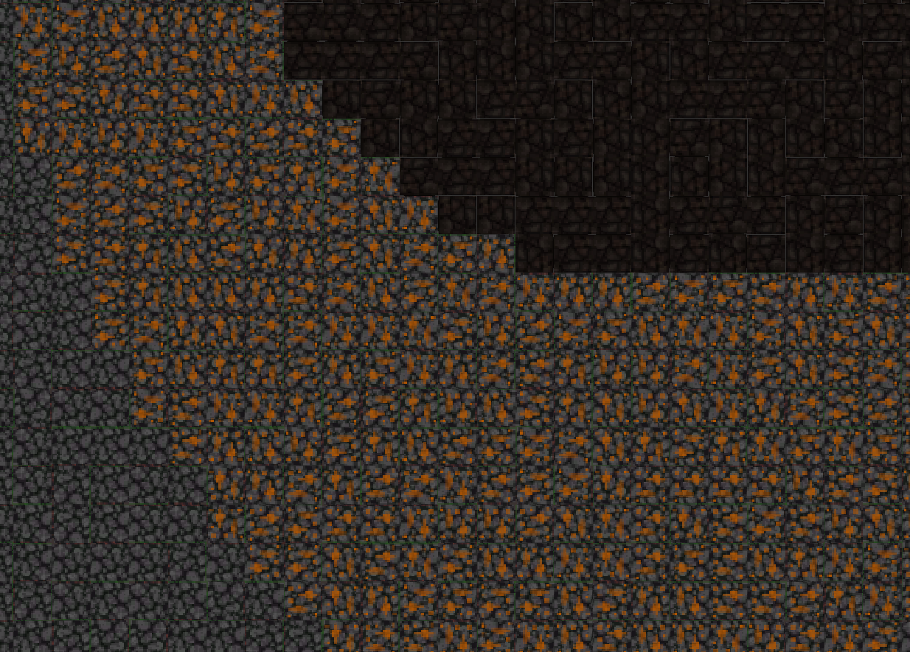
There are different clustered ore veins, which all feature a different rarity (so copper is less rare then diamond so it appears more frequently) are categorised by the different ores as seen in the world photo above are colour coded as:

Copper – Orange
Iron – Brown
Gold – Yellow
Diamond – Blue
Copper Ore vein
Silver – White

Game Characters

The player’s character


Enemies and Monsters
AI in its Following/firing state


AI in its static/dormmate state

The AI is a flying circular robot that is dormant until a player is in range. Upon reaching this range the AI will begin shooting at the player and trying to eliminate them. The robot is small and aggressive in nature. It will also fly towards the player attempting to follow them, but if the player is skilled and clever enough, they can be evaded with little difficulty.

User Interface

Overview
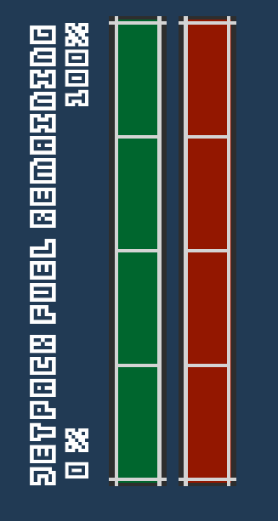
The user interface contains only the most important details to the player, like their health, name, Jetpack fuel, current collected ore count for each ore, etc. this allows the player to focus more on gameplay rather than trying to learn a new UI to them.

User Interface Detail #1
The health and jetpack fuel sections of the UI both go together as they are both vertical sliders so they both get smaller when depleted. They are situated on the lower right hand side of the UI

User Interface Detail #2 – ore count
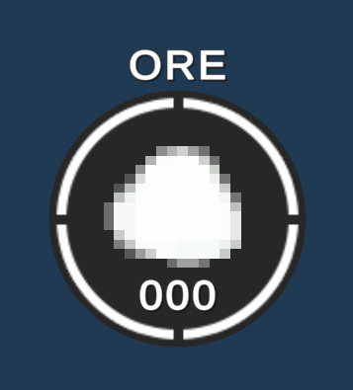
The ore section of the UI is made up of several of these sections as shown on the right, so there will be several of these elements on the lower left hand of the screen, one for each ore type. The top of the element is the ore name, the middle is the ore colour and a white filling circle for visually showing how full is your inventory, and a value of how much ore you have of that type.

Weapons

Overview
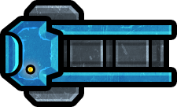

The main weapon used in the game is a missile launcher/cannon. It shoots a physical projectile that blows up on impact causing an explosion.

Weapons Details #1
Weapons Details #1

Weapons Details #2
Weapons Details #2

Musical Scores and Sound Effects

Overview

This should probably be broken down into two sections but I think you get the point.

Red Book Audio

If you are using Red Book then describe what your plan is here. If not, what are you using?

3D Sound

Talk about what sort of sound APIs you are going to use or not use as the case may be.

Sound Design

Take a shot at what you are going to do for sound design at this early stage. Hey, good to let your reader know what you are thinking.

Multiplayer Game

Overview

Describe how the multiplayer game will work in a few sentences and then go into details below.

Max Players

Describe how many players can play at once or whatever.

Servers

Is your game client-server or peer-to-peer or whatever.

Customization

Describe how the players can customize the multiplayer experience.

Internet

Describe how your game will work over the internet.

Game Sites

Describe what gaming sites you want to support and what technology you intend to use to achieve this. Perhaps Dplay or TCP/IP or whatever. It is probably a good idea to break the tech stuff out into a separate area, you decide.

Persistence

Describe if your world is persistent or not.

Saving and Loading

Explain how you can save a multiplayer game and then reload it. If you can or why this is not possible.

Character Rendering

Overview

Provide an overview as to how your characters will be rendered. You may have decided to include this elsewhere or break it out to provide more detail to a specific reader.

Character Rendering Detail #1

Character Rendering Detail #2

References

Book
Author(s) - family name, initials. (Year). Title of book. Edition. Place of publication: Publisher.
[1] Doe, B. (2013). C++ for Game Developers. Indianapolis: John Wiley & Sons.
Report
Author(s) - family name, initials. (Year). Title of report. Edition. Place of publication: Publisher. (Series and vol./no.).
[2] Burrows, D., et al. (2012). Global Trends: Alternative Worlds. Washington: National Intelligence. (Office of the Director of National Intelligence).

Web-site
Author(s) - family name, initials. (Year, month day). Title of document. [Online]. (URL). Place of publication: Publisher. (Date accessed).
[4] de Valk, J. (2014, May 12). AI for Games. [Online]. (URL https://www.somesite.com/articles/1234/). (Accessed 12 February 2014).

